Welcome to Dubai, March 6-9 2018

Dear friends of the GKPN. Greetings.

After a very successful meeting in Lima, a month ago, we are ready to invite you to join the 10th anniversary of the GKPN during our meeting in Dubai.

Pastor Jim Burgess and his wife, Alanda, will be our hosts. They are the leaders of the Fellowship of Dubai Church, and a much beloved couple. They are fully engaged in this initiative, and have put their staff completely available to make the upcoming meeting a great success.

I had the pleasure of visiting Dubai once again, and the contract has been signed and the deposit paid for our group. We will be staying in two hotels – both part of the same complex. St. Regis hotel is a luxury collection hotel. We will use the hotel ballroom and patio for our meetings and lunches. 15 of us who would like to be in one of the incredible rooms of this hotel, even if paying a little more for that, can choose this option. The other hotel is the Westin Dubai, Al Habtoor City, a truly 5 stars hotel, and part of the same three hotels complex. We got 1115 rooms at Westin.

Dubai is an incredible place, and we will have plenty of time to get to know the city and their evening attractions. We will also celebrate the many accomplishments of the network in its 10 years, the benefits of the network for our individual networks and ministries, and we will learn from one another about improving our ways to move ahead, grow our churches and ministries, and be a force for the advancement of God’s kingdom in the world.

Welcome to Dubai 2018.

Elias

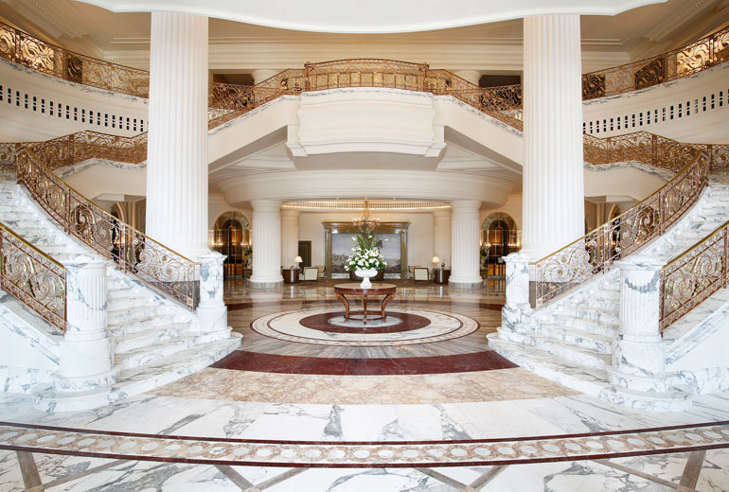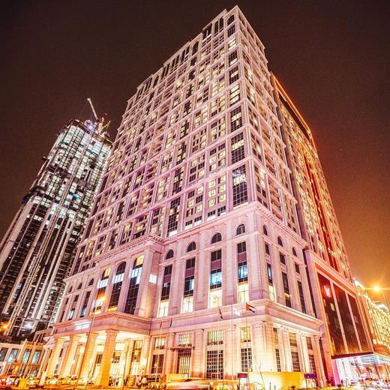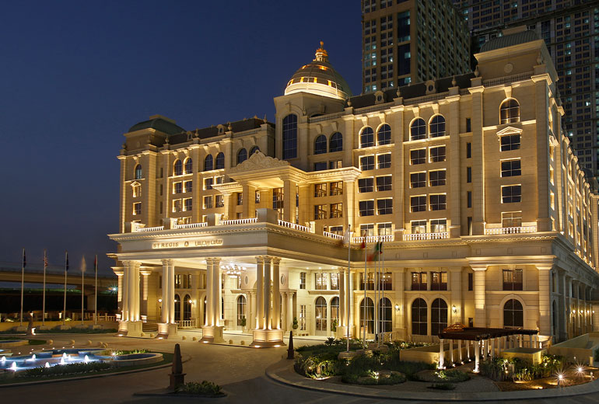

[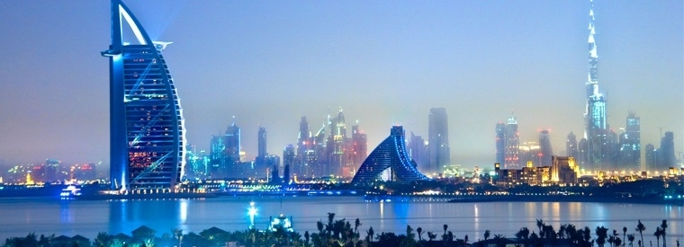](https://www.viator.com/Dubai/d828)